The Simulation of Br Atoms on Cu (111) Surface

Shen Chen1,Tao Lin1 and Nian Lin1 (Supervisor)

1 Department of Physics, Hong Kong University of Science and Technology,

Clear Water Bay, Kowloon, Hong Kong  
schenad@ust.hk

**Abstract.** The purpose of the project is to simulate the behavior of Br atoms on Cu (111) surface using Monte Carlo algorithm [1], and a modified version of this algorithm, which is called simulated annealing, is also operated. As observed in experiments, when Br atoms on Cu (111) surface were slowly cooled down to a quite low temperature, steady Br islands were formed. Then, the size distribution and the pair correlation function of these islands are studied, which were used to determine the parameters in the simulation model. After setting up the model, we further studied the system under different temperature and observed the phase transition in simulation.

**Keywords:** Monte Carlo algorithm, simulated annealing, Br atoms, Cu (111) surface, phase transition

1. Introduction

The experiment part of this project was done by Shiyong Wang, who was a graduated PG student in HKUST. He initially randomly distributed the Br atoms on the Cu (111) surface at about 300K while cooled down the sample. When the temperature was around 50K, the Br atoms started to form some localized islands. As the temperature reached to ~5K, the atoms seem to be “frozen” and the steady islands were formed. Fig. 1 is the STM image provided by the experimenter.

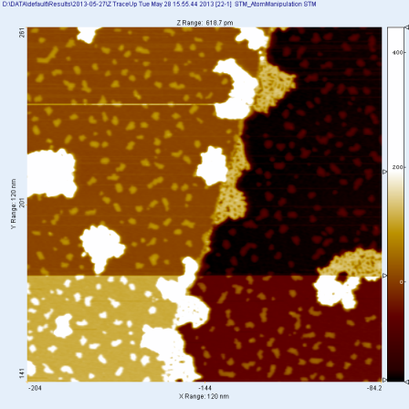

Fig. 1. STM image of the Br islands on Cu surface. The large white speckles are molecules; the small ones are Br islands

To study this phenomenon, a normal Metropolis Monte Carlo algorithm was used in the first stage of this project. However, later study shows that, to achieve a reliable simulation result, the algorithm cost quite a long time. Therefore, we modified the original program according to simulated annealing algorithm, which could accelerate the program by 10 times. By comparing the size distribution and the pair correlation function of the Br islands in the STM image and in simulation, the consistence of the character of the Br islands could be verified, and the parameters in the simulation model could be approximately determined. Furthermore, we increased the temperature in this model and observed the phase transition in this system, which will be discussed in the following paragraphs.

1. Simulation
   1. Modeling

A 100 $×$ 100 triangular grid graph is used in this simulation as the “lattice”. It is defined that “Br atoms” can only move among the lattice points. During a step, a randomly chosen atom will be moved, giving a fluctuation to the system. The energy difference of the system before and after moving, denoted by ∆E, is defined by the following equation:

$∆E=-E_{b}×{∆N}_{b}+∆(\sum{A×\frac{1}{r^{3}})}$ (1)

where $E_{b}$ is the bonding energy of one bond between adjacent atoms, $N_{b}$ is number of bonds formed around the chosen atom, A is a constant and r is the distance between the chosen atom and any other atoms on the lattice. The summation means summing up all the repulsion energy between the chosen atom and the other atoms on the plane.

Then, the possibility to accept the step defined to be the min{1, $e^{-\frac{∆E}{k_{B}T}}$}. The temperature was set to be 5 K, which is the same as the experiment condition.

* 1. The number of operating steps

In the experimental case, since the system should reach its lowest energy state by annealing, we also need to achieve the lowest energy state in simulation. However, it is quite hard to define whether the system reached the lowest energy in simulation.

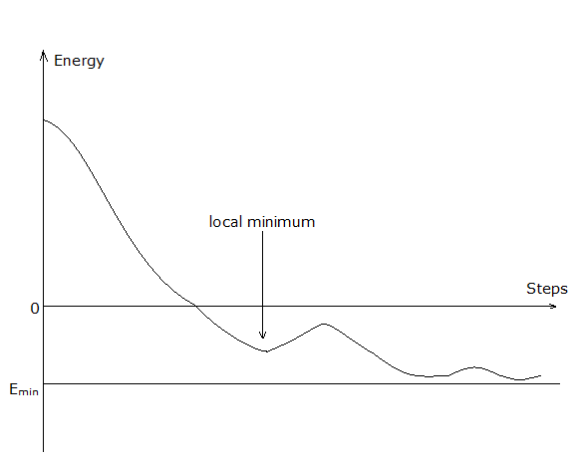

Fig. 2. The imaginary energy curve of the simulation model.

As shown in Fig. 2, though the total energy of the system tends to decrease as the steps increasing, the local minimum may not be avoided, and it is easily to mistake it for the lowest energy, as demonstrated in the project done last fall. Therefore, the safe way is running the program for enough steps. In practice, we had to run it for 109 steps at a specific temperature to ensure the system in its lowest energy state.

However, the disadvantage is that the huge number of steps may take a long time for the program to run a trial (~50 hours for low coverage, ~300 hours for high coverage). Therefore, we introduced the simulated annealing algorithm to speed up the process. This algorithm mainly let the temperature initially higher than the target temperature, then decrease the temperature linearly in the first half of the steps to the target temperature, and let the system run at the target temperature for the other half of the steps. In practice, we need totally 108 steps to get a reliable result using this method. The simulation results and the comparison between the experimental result and simulation will be discussed in the following sections.

1. Characterization of the Br islands

By analyzing the STM image and the simulation results, some characters of the Br islands could be observed. As already being discussed in the former project report, we only have experimental data in three cases, which are low coverage (0.1092ML), medium coverage (0.3365ML) and high coverage (0.7195ML) of Br atoms. Therefore, it is nature to set the Br atom coverage in simulation to be the same as the coverage in experiment so that we could compare the experiment and simulation to get the

* 1. Experimental results

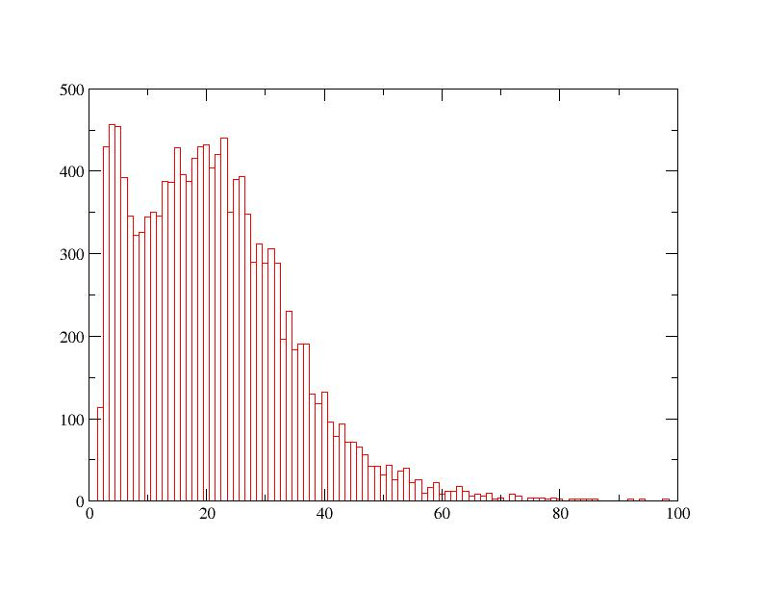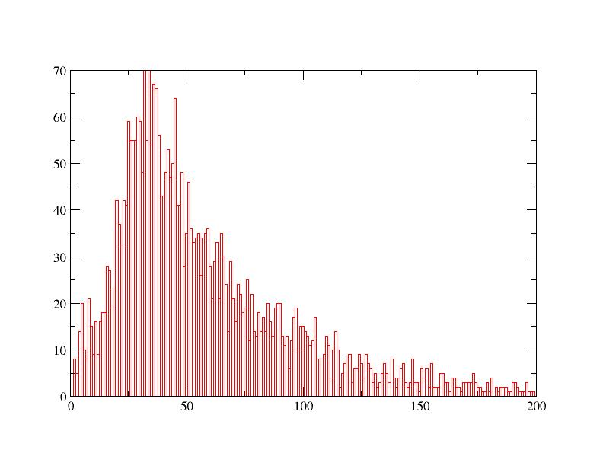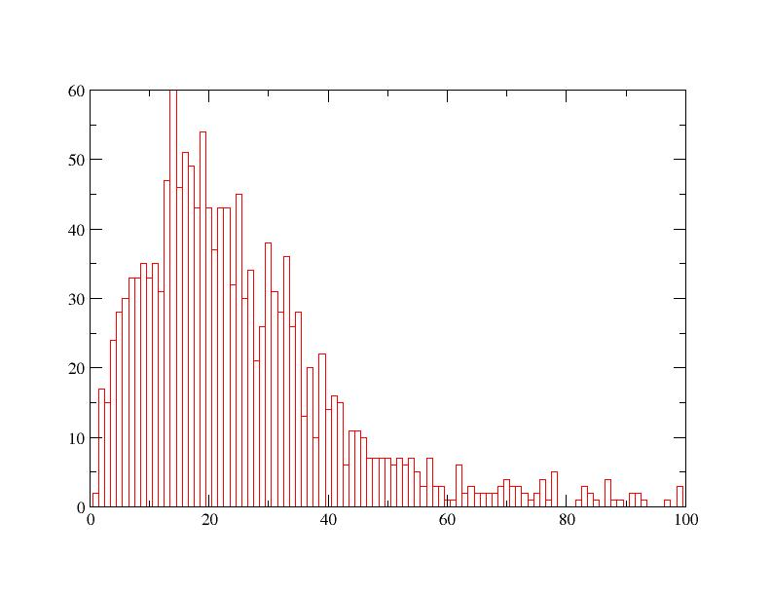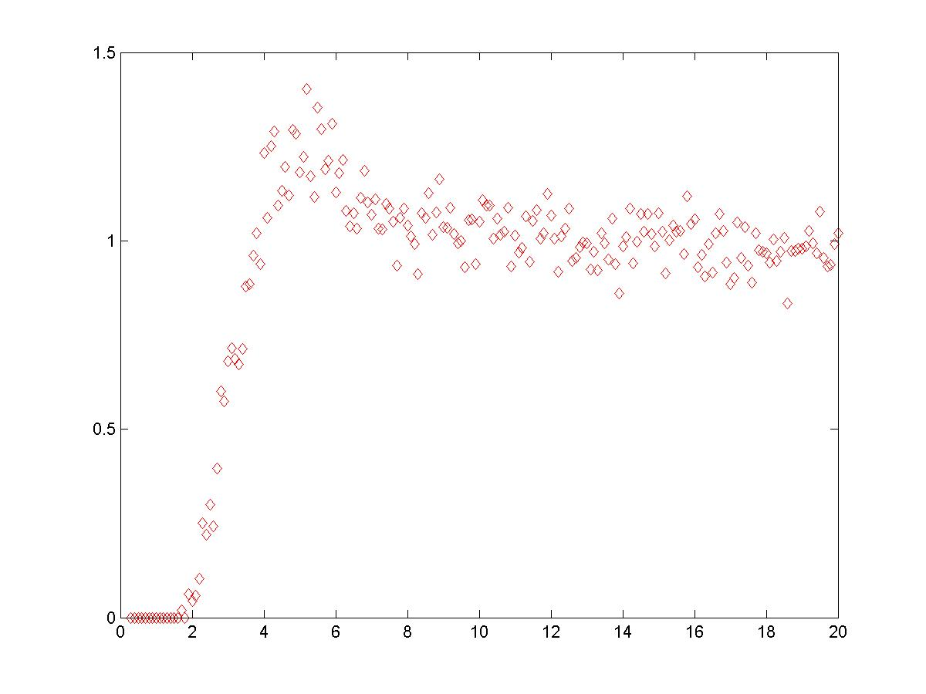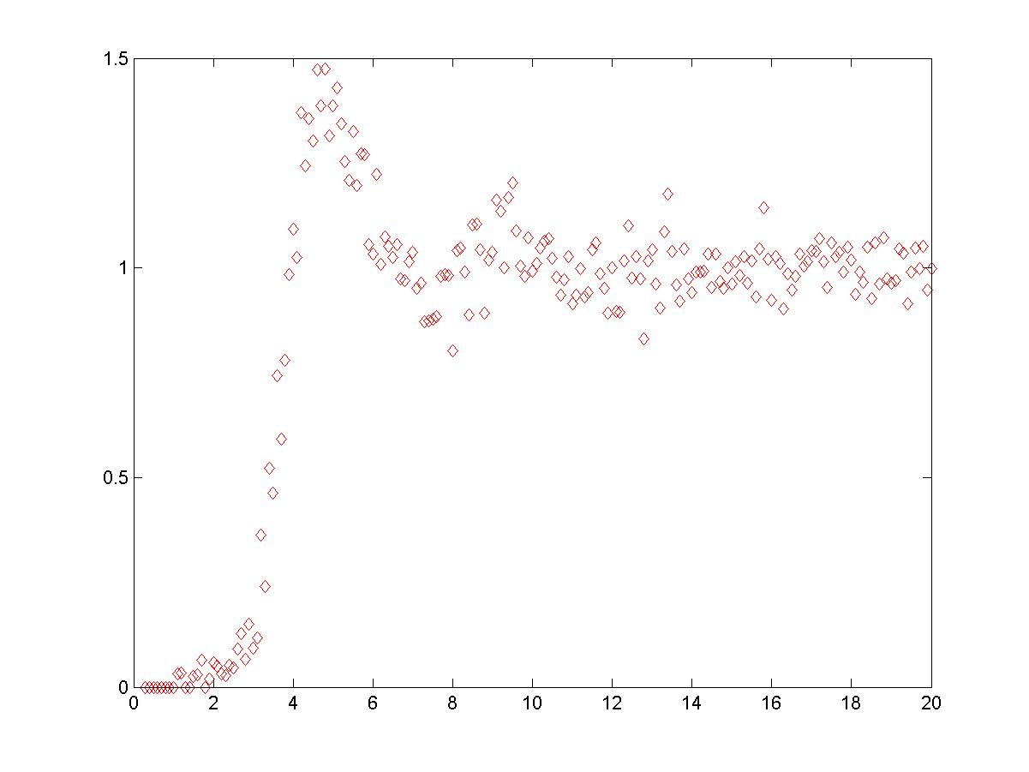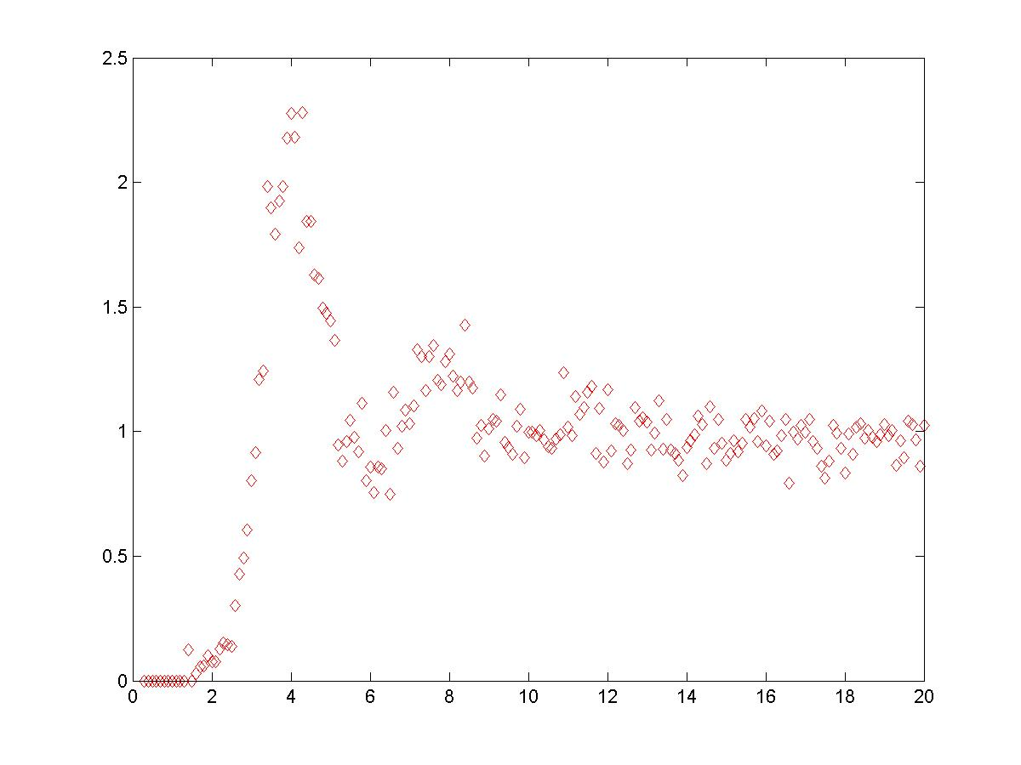

0.1092 ML 0.3365ML 0.7195ML

Fig. 3. Size distribution and pair correlated function of the Br islands in the experiment with the low coverage (0.1092 ML), medium coverage (0.3365ML) and high coverage (0.7195ML)

Fig. 3 shows the main character of the Br islands we considered, which are size distribution and pair correlation function. The value of the size of a Br island is defined by the number of the Br atoms in this island. If it is a single free atom, its size defined to be 1. The peak position of these distributions could be summarized in the following table.

| Coverage | Size distribution | Pair correlation function |
| --- | --- | --- |
| 0.1092ML | 21 | 5 |
| 0.3365ML | 30 | 4.75 |
| 0.7195ML | 14 | 4 |

Table1. Peak position of different character of Br islands under different converges.

* 1. Simulation results

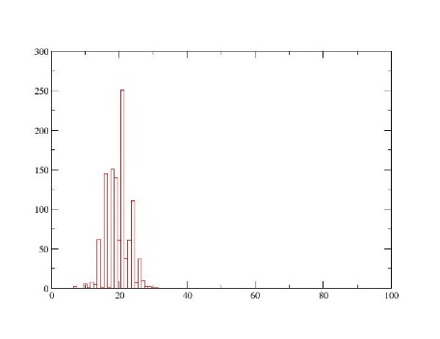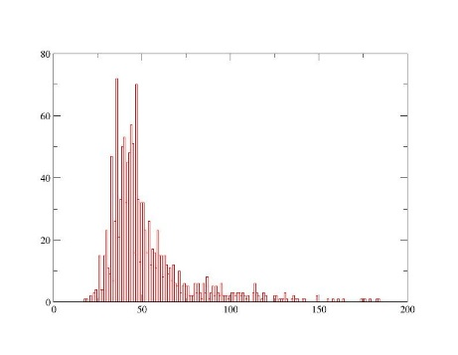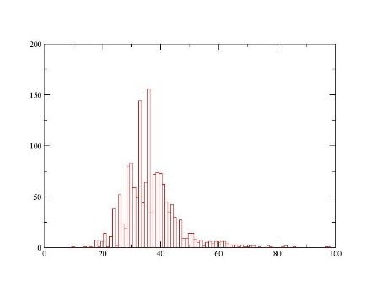

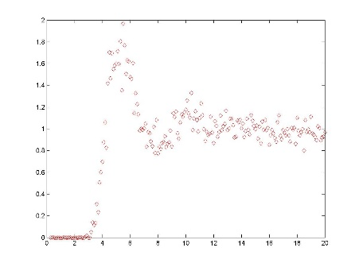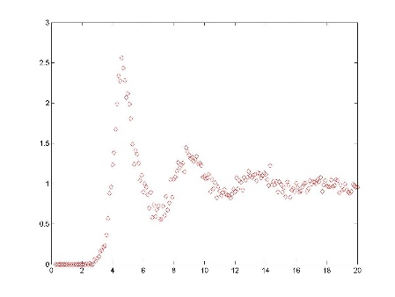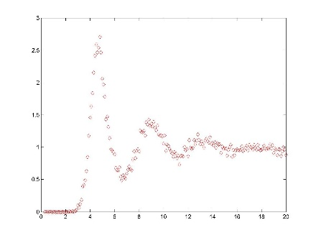

0.1092 ML 0.3365ML 0.7195ML

Fig. 4. Size distribution and pair correlated function of the Br islands in the simulation (T = 4 K, Eb = 0.04 eV and A = 0.01) with the low coverage (0.1092 ML), medium coverage (0.3365ML) and high coverage (0.7195ML)

Similar to the experimental cases, we calculate the size distribution and the pair correlation function for the islands for each coverage, and compare them with the experimental data to determine the unknown constant Eb and A in the equation (1). The process of finding of these parameters will not discussed in this report, since I have discussed it in the report of the project in last fall semester. However, the result got in last fall semester is not accurate, as the steps is not enough for the system to reach its lowest energy state. Therefore we extend the steps and use the simulated annealing to ensure the system is at its lowest energy. But the simulation results would not agree with the experiment if we still use the old parameter. After trying different sets of Eb and A, we finally determined that Eb = 0.04 eV and A = 0.01, which gives the simulation results as shown in Fig. 4. Notice that its island size distribution is not agree with the experiment, but it may cause by the effect of the molecules on surface, which was not taken into consideration in the model.

1. Characterization of the Phase Transition

When the system is assigned a higher temperature, the phase transition of the system may be observed, as the large stable island may no longer be formed under the high temperature. In this project, we studied two cases, which are “without repulsion” (A = 0) and “with repulsion” (A = 0.01). The character to be studied for phase transition are the heat capacity, the first peak of the pair correlation function of atoms and the size of the largest island in the plane. As the program may take a long time to run through different temperatures, we further sped up the program by decrease the lattice size to 30 $×$ 30. And we also verified that the decrease in the size of lattice would not affect the simulation results.

* 1. Heat Capacity

The formula we used is $Cv=\frac{{<E>}^{2}-<E^{2}>}{k_{B}T^{2}}$, where E is the total energy of the system, kB is the Boltzmann constant, and T is the temperature. The total energy consists of bonding energy, repulsive energy and the kinetic energy, which is calculated by KE = NkBT, where N is the number of free atoms with no bond.

For the case without repulsion, the heat capacity – temperature curve is shown in Fig. 5.

Fig. 5. The heat capacity – temperature curve for the system without repulsion (1% means 0.01ML, similar for the rest)

As it is hard to decide the peak position, we use a non-linear fitting in OriginPro 9.0 called “GCAS”. Then we could plot the peak position with related to the coverage. (Fig. 6)

Fig. 6. The peak position of the heat capacity – temperature curve under different coverage for the system without repulsion (1% means 0.01ML, similar for the rest)

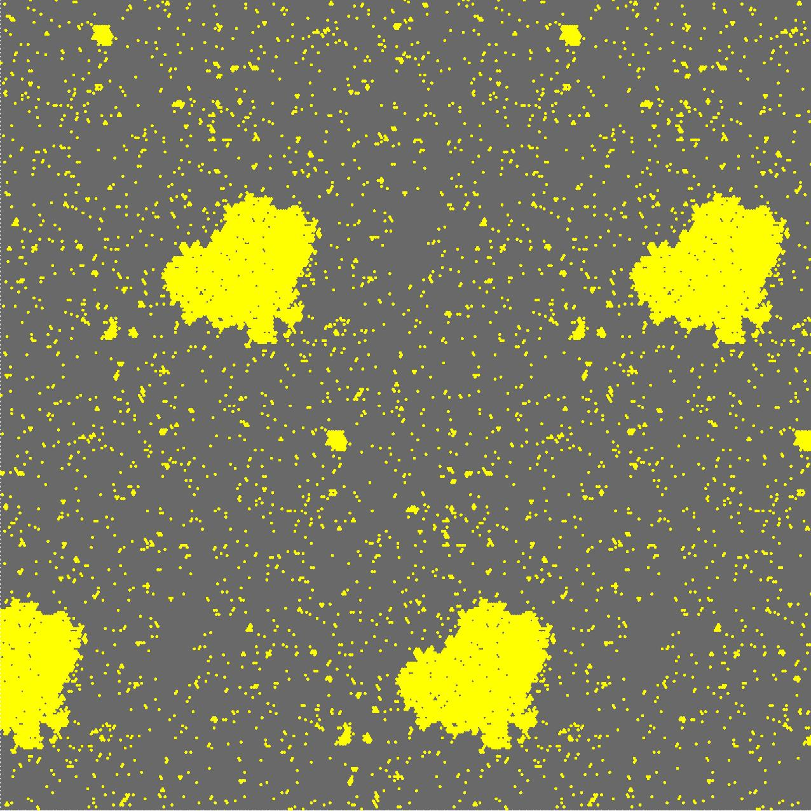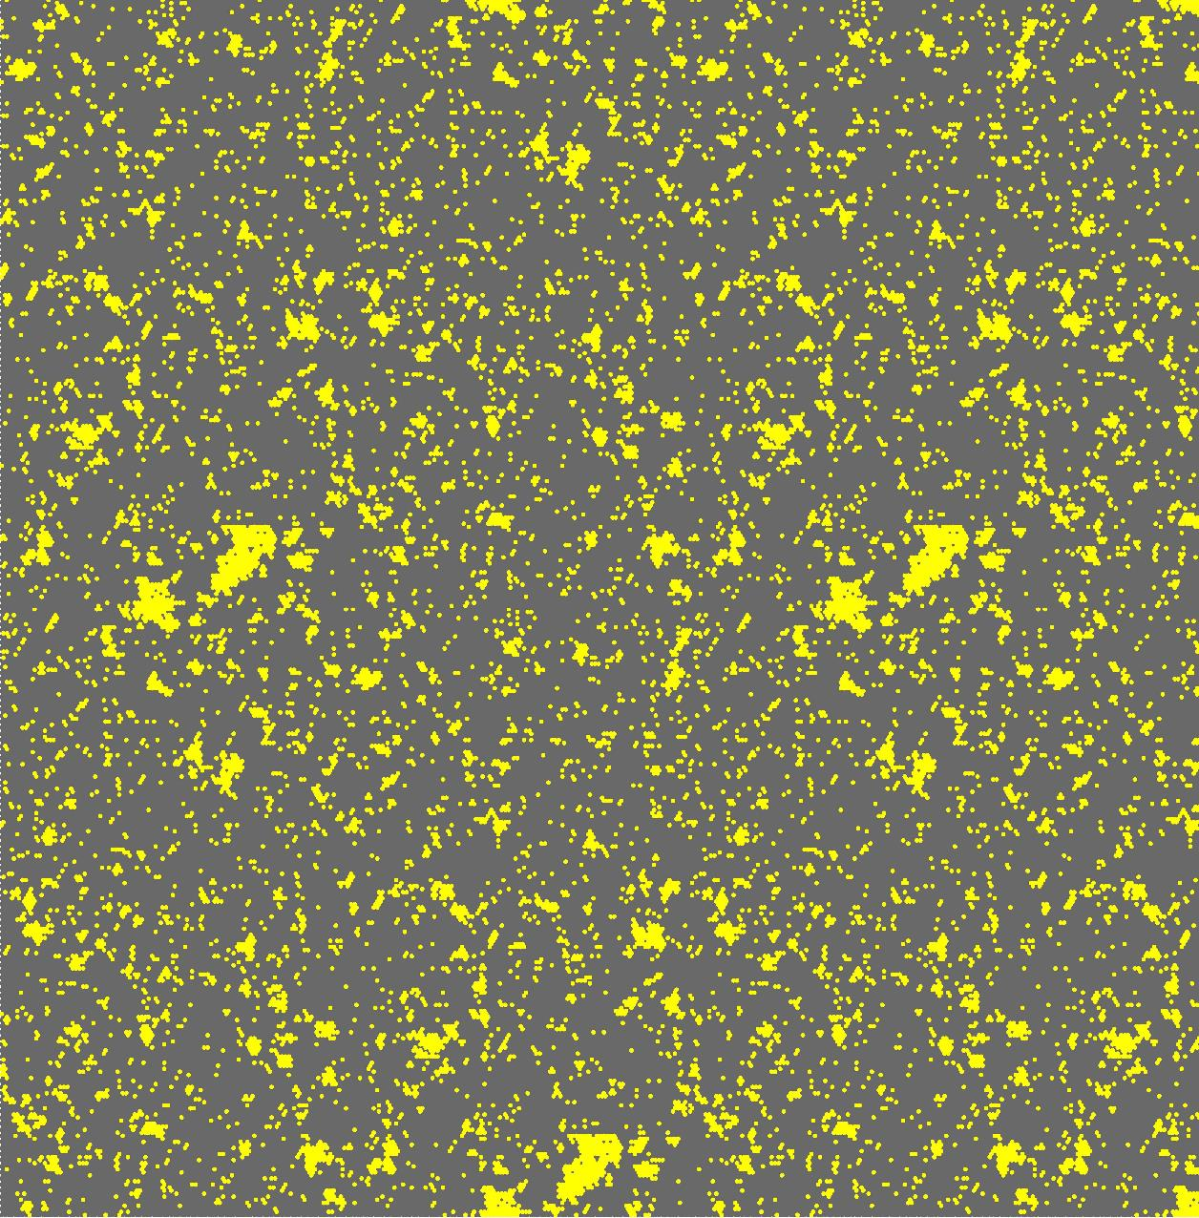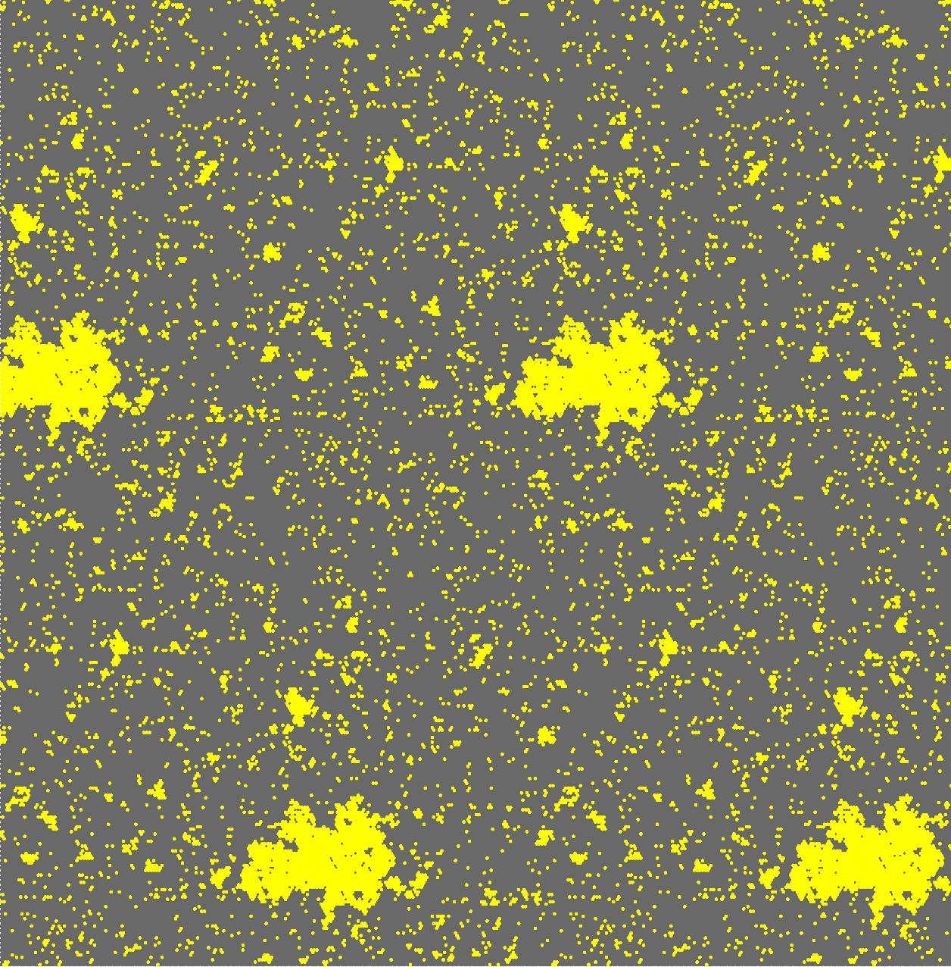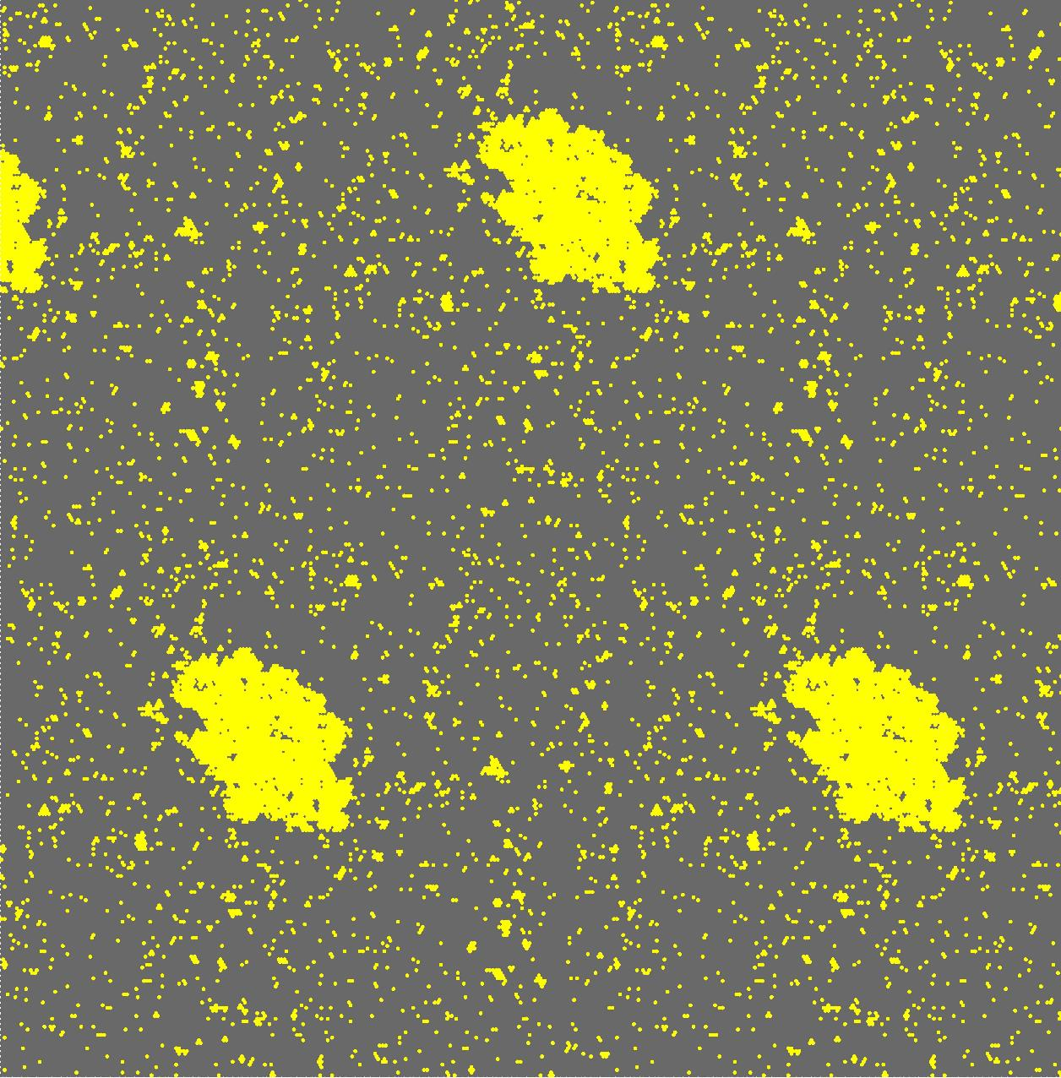To verify that the phase transition really happened around the peak position of the heat capacity – temperature curve, a specific example is demonstrated in Fig. 7, with coverage equals to 0.1092 ML.

356 K 373 K 391 K (Peak) 409 K 427 K

Fig. 7. The simulation result of atoms under different temperatures, showing the phase transition before and after the peak position of the heat capacity – temperature curve

For the case with repulsion, we could do the similar analysis and obtain the results (Fig. 8, 9). Comparing to the case without repulsion, the Cv – T curves generally show lower transition temperatures and broader peaks, which implies a slower phase transition than the case with repulsion.

Fig. 8. The heat capacity – temperature curve for the system with repulsion

Fig. 9. The peak position of the heat capacity – temperature curve under different coverage for the system with repulsion

* 1. First Peak of the Pair Correlation Function for atoms

The first peak of pair correlation for atoms denoted the average number of adjacent atoms to any of the chosen atom, comparing with the ideal gas. Therefore, if the phase transition happens, this value should drop as the Br islands are no longer able to keep its initial structure; it would be broken up into single atoms. Fig. 10 shows the comparison between the case with and without repulsion for a specific example with coverage = 0.1092 ML.

Fig. 10. The first peak of pair correlation for atoms vs temperature when there is no repulsion (on the left), and with repulsion (on the right), with coverage = 0.1092 ML.

Both of these two curves shows a drop around the phase transition point, but the one without repulsion appears to have more significant drop than the case with repulsion, which is much more like a linear decrease.

* 1. The Size of the Largest Island

According to the observation, the largest island is easier to be broken than the small ones when increasing the temperature. Therefore, we also use this parameter as a character of phase transition. Fig. 11 shows the comparison between the case with and without repulsion for a specific example with coverage = 0.1092 ML.

Fig. 11. Size of the largest island vs temperature when there is no repulsion (on the left) on 100X100 lattice , and with repulsion (on the right) on 30X30 lattice, both with coverage = 0.1092 ML.

Again, both of these two curves shows a drop around the phase transition point, but the one without repulsion appears to have more significant drop than the case with repulsion.

1. Summary

In this project, the value of bonding energy Eb and constant A in repulsion term has been decided in the model, then the simulation model was set up. With the help of simulation annealing algorithm, we are able to save lots of time during doing simulation with different temperature. Then we observed the phase transition of this system, and characterized it under the condition without or with the repulsion, which shows the different thermal dynamic property of these two systems.

Acknowledgment

I would like to thank Tao Lin and Shiyong Wang for the experiment data, their Matlab program to calculate the coverage, the pair correlation function, and their assistance of programing.

References

1. Metropolis, N.; Rosenbluth, A.W.; Rosenbluth, M.N.; Teller, A.H.; Teller, E. (1953). "Equations of State Calculations by Fast Computing Machines". *Journal of Chemical Physics* **21** (6): 1087–1092.